Research Outcome Summary
State-Dependent U.S. Equity Sector & Factor Rotation
The research provides evidence that the state-dependent Trend Following SuperSmoother - Accumulation Zones [JW] framework adds value as an active allocation signal, although it does not consistently outperform passive U.S. equity exposure over the available sample.
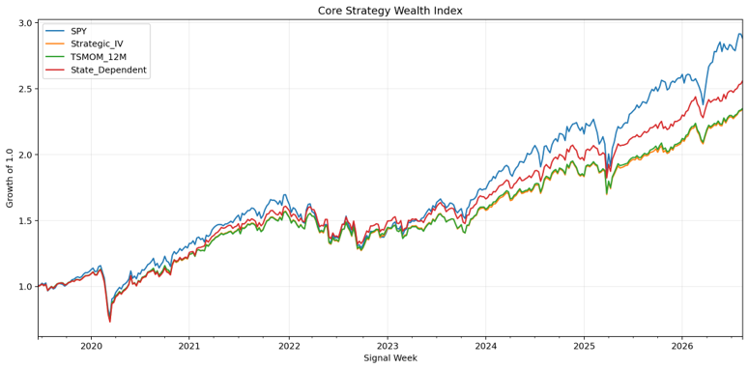

Core Sector Rotation
- Applied to the 11 U.S. sector ETFs, the state-dependent strategy outperformed both the shared inverse-volatility strategic allocation and conventional 12-month time-series momentum (TSMOM).
- The relative advantage remained positive across a broad range of parameter sensitivity tests and when individual sectors were removed one at a time.
- The state-dependent strategy generally required less turnover than TSMOM, helping its relative advantage remain resilient after reasonable transaction costs.
Key limitation: passive SPY generated higher absolute returns over the core sample. The results therefore support incremental signal value within an active allocation framework rather than superiority to passive U.S. equities.

Portfolio Architecture
Alternative treatments of bearish sectors revealed a clear trade-off between return, diversification and downside protection. Completely redistributing capital away from bearish sectors could improve returns but created potentially extreme concentration. Constrained redistribution reduced this concentration but introduced greater cash exposure during stressed periods.
Long/short experiments indicated that bearish states contain relative return information, but bearish assets did not produce negative average absolute returns. The signal therefore appeared better suited to relative underweighting and capital allocation than to a standalone short book.

Systemic-Risk Overlay
A daily overlay combining elevated cross-sector correlation with VIX successfully identified systemic stress and materially improved downside characteristics. Its main weakness was re-entry: VIX and correlation can remain elevated during strong rebounds, causing the portfolio to stay de-risked for too long and sacrifice recovery returns.
Interpretation: systemic-risk indicators appear more useful for fast de-risking, while the underlying trend-state framework is better suited to determining when exposure should be rebuilt.

Factor Portability
The frozen state engine was then applied without parameter re-optimisation to U.S. equity factor ETFs representing momentum, quality, value, size and minimum volatility. The state-dependent factor portfolio outperformed both its strategic allocation and its TSMOM equivalent.
Expanding the opportunity set to a 16-ETF combination of 11 sectors and 5 factors strengthened the relative result.
Combined State Result | vs Strategic | vs TSMOM
Annualised active return | ~+65 bps | ~+59 bps
Information ratio | ~0.51 | ~0.42
The combined state-dependent strategy also exhibited materially lower turnover than the corresponding TSMOM implementation. Because the factor test used the frozen parameters and verified Pine-to-Python parity, the result provides encouraging evidence that the signal is not purely sector-specific.

Overall Conclusion
The strongest interpretation is that the model functions as a cross-sectional capital-allocation framework rather than a conventional market-timing system.
Its principal contribution is not predicting the direction of the U.S. equity market, but using heterogeneous trend states to determine where capital should be relatively overweighted or underweighted across sectors and factors. The transfer of the frozen signal from sectors to factors, together with stronger results across the combined opportunity set, provides promising evidence of broader portability.

Research Limitations
- The ETF history provides a relatively short sample and includes only a limited number of major market regimes.
- The research is concentrated on U.S. equities and has not yet established generalisation across international markets or broader asset classes.
- Parameter robustness is sensitivity analysis rather than true out-of-sample validation.
- Backtested results remain hypothetical and do not establish persistent future alpha.
Overall, the project provides promising empirical evidence that state-dependent trend information can improve systematic cross-sectional equity allocation, while retaining a clear distinction between incremental active-signal value and total performance relative to passive SPY.

